Data Mining II: Advanced Methods and Techniques

Laboratory Assignment II:

Questions – Part A:
- Create a truth table for the XOR problem. Proceed with the following:

  - Demostrate the backpropagation algorithm for learning the XOR function, using the following weights as initial random weights:
output

z
2.2
2.5
y
x
5
4.6
-4.9
-5.1
b
a

inputs

Show each neuron output value in the forward direction, and the weight change in the backward direction, using the backpropagation algorithm, for each row of the truth table. Assume that the threshold function for the neuron is 0.01, which means that if the sum of the inputs is less than 0.01, the neuron will output a 0. Moreover, if the sum of inputs >= 0.01, the neuron will output a 1.
Truth Table:
0 | 0 | 0
1 | 0 | 1
0 | 1 | 1
1 | 1 | 0
Pass 1:
-4.9*0+5*0 = 0 => x = 0 because x!=>0
4.6*0+(-5.1)*0 = 0 => y = 0
0*2.2+0*2.5 = z = 0
Parameters:
Target = 0; Delta = 0;
---Backpropagation on weights:
W1 = W1 + delta*input = W1
W2 = W2 + delta*input = W2
Delta1 = delta*W1 = 0
Delta2 = delta*W2 = 0
W3, W4, W5, W6 remain unchanged because delta = 0;
Now we would continue with a new target value of 1, and therefore delta = -1, and we would watch the weights change and the error decrease.

  - Using the truth table, produce an .arff file to be entered into the Weka Neural Network classifier. Preprocess the data. You will be using this dataset to conduct different neural network experiments by modifying the neural network topology, the learning rate, the number of epochs to train, etc.
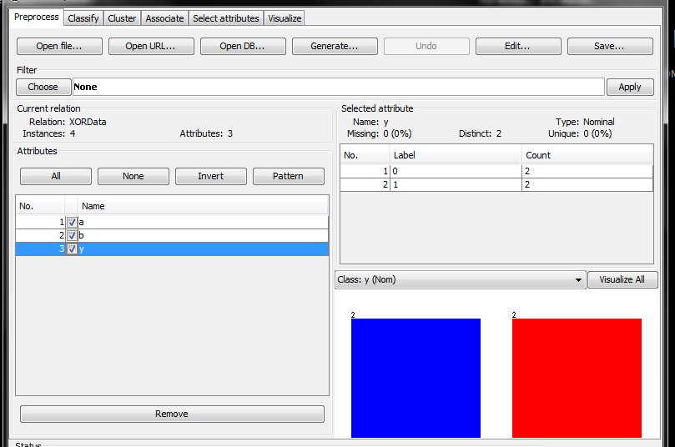

  - Build the most accurate neural network for predicting the XOR function value using Weka’s neural network classifier. Experiment with two different configurations, two different learning rate values per each configuration, as well as two different numbers of training epochs. Describe all six of your experiments in enough detail that they can be reproduced.

Experiment # | Learning Rate | Training Epochs | Mean Absolute Error
1 | 0.3 | 500 | 0.5
2 | 0.5 | 500 | 0.4985
3 | 0.8 | 500 | 0.2929
4 | 0.3 | 100 | 0.5
5 | 0.3 | 1000 | 0.4995
6 | 0.3 | 2000 | 0.2574

The Backpropagation Algorithm learns the weights for a multilayer network by using the gradient descent rule in order to search for a global minimum in the hypothesis space and calculating a direction of steepest descent. The values of the weights are “learned” through sequences of iterations which, at each pass, minimize the distance between the network output values and their target values.

By learning rate, we refer to a scalar that is used to derive the “delta of the weight” or in other words to control the change in the weight at each pass. By increasing the learning rate, we magnify the change in the weight at a specific pass, which is what we want to do if the algorithm is leading us in the right direction (i.e. towards the global minimum). When the learning rate is increased, we have a larger change in the weights at each iteration, thus approaching the target values faster and decreasing the error more quickly.

By training epochs, we refer to the number of iterations the algorithm’s loop will perform until the value is reached. As we see in the table above, the more epochs we have, the more passes through the loop and therefore the more iterations we have to improve the accuracy of the weights.

- Create a truth table for the following function: p = (x OR ~y) AND (x OR ~z). Proceed with the following:
  - Using the truth table, produce an .arff file to be entered into the Weka Neural Network classifier. Preprocess the data. You will be using this dataset to conduct different neural network experiments by modifying the neural network topology, the learning rate, the number of epochs to train, etc.

  - Build the most accurate neural network for predicting this function value using Weka’s neural network classifier. Experiment with three different configurations, varying the learning rate and number of training epochs of your choice. Describe all three of your experiments in enough detail that they can be reproduced.
Truth Table
X or Not Y: | X or Not Z | P
1 | 1 | 1
1 | 1 | 1
0 | 0 | 0
1 | 1 | 1
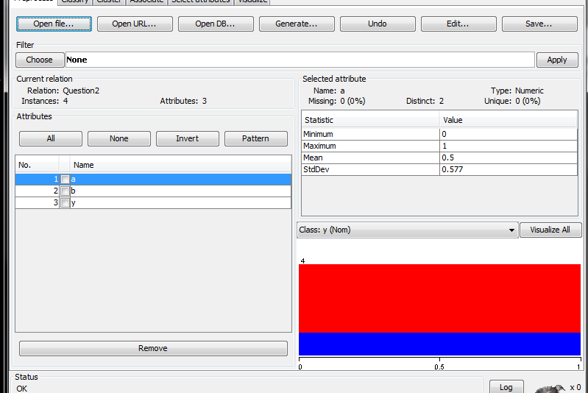
Experiment # | Learning Rate | Training Epochs | Momentum | Mean Absolute Error
1 | 1 | 10000 | 0.2 | 0.005
2 | 1 | 10000 | 0.4 | 0.0043
3 | 1 | 10000 | 0.6 | 0.0035
4 | 1 | 10000 | 1 | 0
5 | 1 | 1000 | 1 | 0
6 | 1 | 500 | 1 | 0
7 | 1 | 10 | 1 | 0.2812
8 | 0.3 | 10000 | 1 | 0
9 | 0.1 | 10000 | 1 | 0
10 | 0.1 | 100 | 1 | 0
We already observed the behavior of the learning rate and training epochs parameters in the previous question, so I added momentum to it. Momentum is a variation of the gradient descent algorithm which consists in the conditioning of the new updated weight by the previous instance of the same weight, multiplied by a scalar which reflects the parameter itself. Thus, the higher the scalar, the higher the impact of the previous iteration’s weight value upon the next one. The purpose of momentum is to “speed up” the process of convergence toward the global minimum, and potentially avoid getting stuck at a local minimum (which is possible when the stepsize is small, but less likely the higher the momentum as the step will “break-through” the local minimum).
As shown in the first experiments, all other things equal the error decreased as momentum increased. A possible explanation of this behavior is that the descent converged faster towards the minimum, thus leaving a lower error in the last epoch.
As we proceed with down the table of experiments, we tested the importance of Momentum compared to the other two parameters; when momentum was at its maximum, number of training epochs only made a difference at its low end, but there was no difference when we made 500 and 10000 iterations.
When momentum was high, the learning rate did not make as much an impact as before either: dropping the parameter down to 0.1 and using only 100 iterations resulted in the same error as when using a higher learning rate and more epochs.

Questions – Part B:
- Use either the CPU dataset or the Iris dataset. These .arff files are usually found in the data directory when you start Weka. Preprocess the data. Build a neural network model of this dataset by testing several configurations, the learning rate values and training time. Report the most accurate neural network you built in enough detail that it can be reproduced.
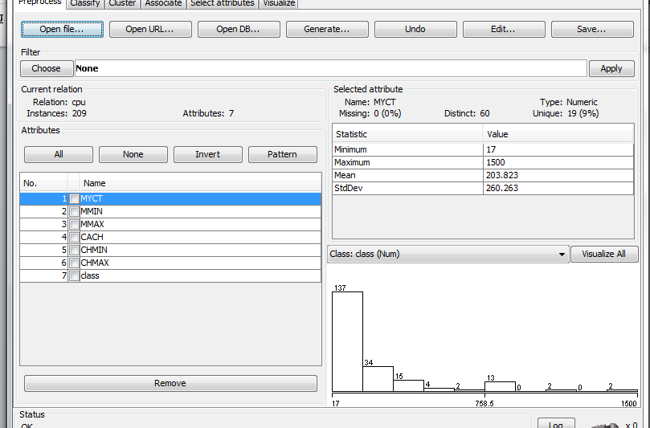

I used the CPU dataset:
All things equal, the relative error seemed to be at its minimum when choosing option “i” for the number of hidden layers (parameter –h). The error was still very high though (over 400%) so I modified. My parameters were unchanged from the previous example, so I had learning rate = 1, and momentum = 1; I increased the number of epochs tenfold to 10’000 but the relative error actually increased to over 500%.
I realized this might be because the momentum was so high, it doesn’t matter how many iterations we are going to do because a high momentum will point the step in the wrong direction and as we have more iterations, we simply go farther away from our target. I decreased momentum to 0.2 and obtained relative absolute error = 29%. I then set momentum to 0 and obtained a slightly higher error to 36%.
I then readded the momentum at 0.2 and decreased the learning rate to 0.4, obtaining relative absolute error at 25%, and to 0.2, with the same error result. I tried bringing back a higher momentum, and different values resulted in a higher relative error, but 0.8 actually decreased the error to 22%. I also tried modifying the number of layers again, but option t was the only one that gave me a similar result while all other options created large error.
Finally, I decreased the learning rate to 0.01 to gain better fit and the error dropped to 18%. Then I made it 0.001 and the error increased again – I believe with too little of a change in weight per iteration, the algorithm wasn’t able to converge quickly enough – so I made 100’000 epochs thinking more iterations would give me more precision, but ended up at 17% which is a very small improvement.

- Built the most accurate neural network from a dataset available via UCI KDD archive: http://kdd.ics.uci.edu/summary.data.alphabetical.html. Describe how you came to the model you decided to keep. Report your findings in enough detail that they can be reproduced.
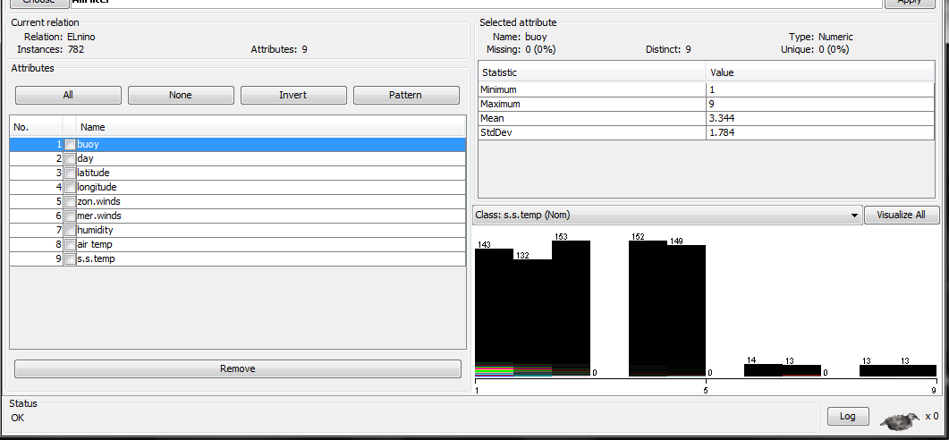
I used Elnino dataset: this dataset tracks measurements of temperature and geolocation for a multitude of buoys throughout a two week time period. The dataset was too large so I only used the buoy, day, and latitude attributes.
The lowest relative error I was able to achieve was 100%; modifying momentum and number of passes did not seem to have an influence. Perhaps because the removal of most attributes renders the remaining dataset meaningless?

=== Evaluation on training set ===
=== Summary ===

Correlation coefficient 0.0206
Mean absolute error 4.1341
Root mean squared error 4.99
Relative absolute error 100.1621 %
Root relative squared error 100.1046 %
Total Number of Instances 782
.

